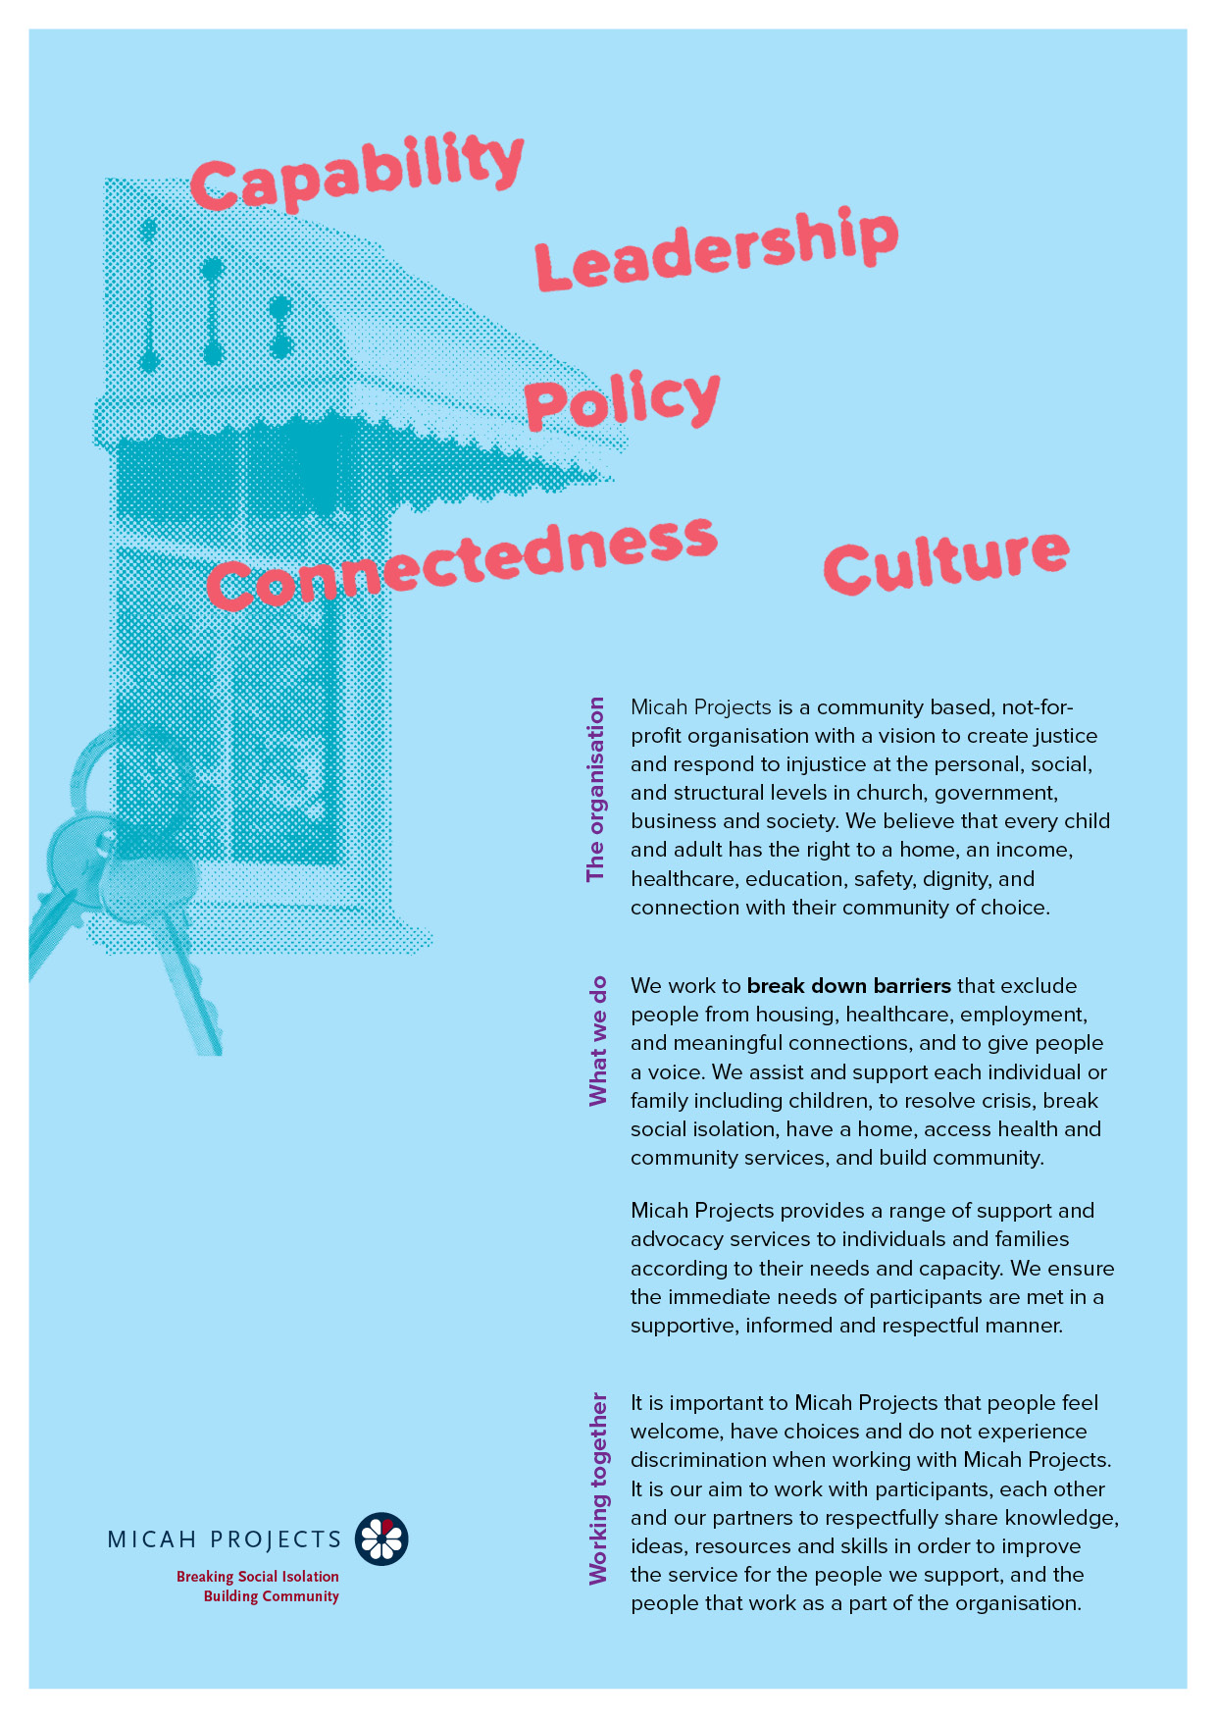
Nourishment & Connection Volunteer
Volunteer

Equal Opportunity  Micah Projects is an equal opportunity employer and promotes access to positions to individuals from a diverse range of social and cultural groups. We acknowledge the First Peoples of Australia as the traditional owners of this land and support their right to self-determination and cultural expression. We recognise that Brisbane is a diverse community and acknowledge the needs of individuals, families and communities relating to age, gender, disability, sexuality and economic status. | Child Safe Organisation  Children and young people are entitled to live in a caring and nurturing environment and to be protected from harm and exploitation. Micah Projects is a child-safe and child-friendly organisation that prioritises the safety and wellbeing of children and young people. We actively provide guidance for management, staff and others in identifying and responding to concerns about the abuse or neglect of a child or young person in contact with the organisation.
Quality statements  Micah Projects is committed to adhering to well defined, effective procedures that are designed to ensure the quality of our services and activities. We expect staff to understand the relevance and importance of their activities and how they contribute to achieving the quality objectives, and to proactively work and operate within the organisation’s quality system. | WHS Statement  Everyone has a right to feel safe at work, and Micah Projects is committed to minimising the risk to any staff member, student, volunteer, contractor, consultant and Board member within the organisation. We work collectively to comply with the Work Health and Safety Act 2015.


Position Overview

Position Title | Team
  Volunteer – Nourishment & Connection
  Wellspring Women and Girls’ Health Hub
Reports to | Line Manages
  Cluster Lead
  NA
Employment Status | Hours of Work
  Volunteer
  3-4 hours per month (2nd Wednesday of the month)
Based at
Caboolture

Micah Projects – Wellsprings Moreton Bay - Wellspring Women and Girls’ Health Hub

The Women and Girls’ Health Hub is funded by Queensland Health to offer services to all women and girls with a focus on priority communities of women and girls who experience worse long-term health outcomes than the general population, due to significant barriers that impact these communities such as lack of culturally safe and appropriate health care. The Hub offers a mix of medical, nursing, counselling, and social services. True Relationships and Reproductive Health and Women’s Health and Equality Queensland also provide services from the Hub.

Position Description

As a Nourishment & Connection Volunteer, you will….

The Nourishment & Connection Volunteer plays an important role in creating a warm, inclusive, and caring environment for women attending the monthly Women’s Community Lunch.

Through planning, preparing, and cooking food, and offering a friendly and welcoming presence, this role helps foster connection, dignity, and a sense of belonging.
The role is central to building a safe and nurturing space where women feel welcomed, valued, and supported to connect with others and with the hub.

Responsibilities  Meal Planning & Preparation  - Plan a simple, nutritious meal or shared food offering for the Women’s Community Lunch  - Prepare and cook food in line with food safety and hygiene requirements  - Consider dietary needs and preferences where possible (e.g. vegetarian, cultural needs)  - Assist with setting up, serving, and packing down the meal area  Creating a Welcoming Environment  - Greet women in a warm, respectful, and non-judgemental manner  - Help create a relaxed and welcoming atmosphere that encourages connection and care  - Support informal conversations while respecting personal boundaries and choice  - Be attentive to the emotional safety and comfort of participant  Collaboration & Care  - Work alongside hub staff on the day  - Follow guidance from staff regarding the flow of the community day  - Raise any concerns about safety or wellbeing to staff promptly | Interactions and Relationships
  - Participants
  - Other Hub team members and external partner organisations
  - Volunteer Coordinator

Criteria and Conditions

Driver’s License: Preferred but Not Essential | Travel: Optional
Criminal History Screening: Blue Card | Assets: N/A

Essential
» Experience cooking for groups or community events
» Knowledge of basic food safety and hygiene practices
» Experience volunteering or working in community, women, or wellbeing settings
» Enjoyment of cooking and preparing food for others
» Friendly, approachable, and respectful manner
» Ability to create a welcoming and inclusive atmosphere
» Reliability and ability to work as part of a team
» Understanding of boundaries in a community support setting
» A referee who is not a relative and can verify your character and interaction in the community.

General Conditions
» All volunteers are to exhibit the values of Micah Projects, as outlined in the Code of Conduct.
» All volunteers must utilise Micah Projects systems to facilitate the quality of the organisation’s work and services.
» Appointment to this position will be subject to a criminal history check, as outlined in the organisational Criminal History Screening Policy.
» All volunteers will comply with Workplace Health and Safety legislation as outlined in organisational policy and procedures.

Volunteer Expression of Interest

