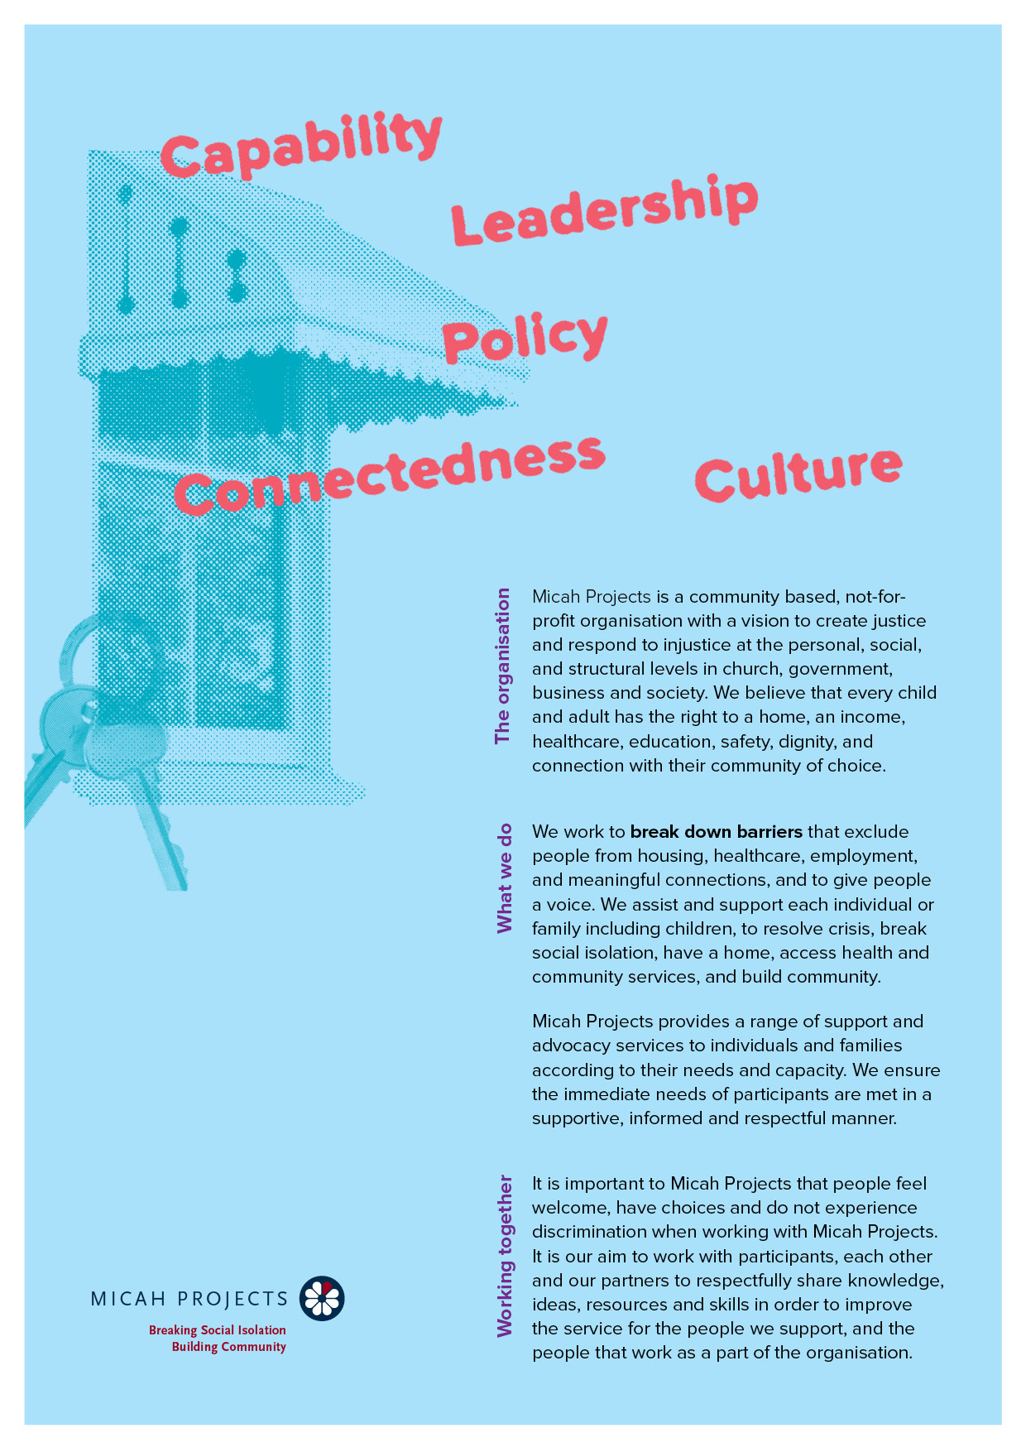
Quality Risk and Performance
Policy Administration Volunteer
Volunteer

Equal Opportunity  Micah Projects is an equal opportunity employer and promotes access to positions to individuals from a diverse range of social and cultural groups. We acknowledge the First Peoples of Australia as the traditional owners of this land and support their right to self-determination and cultural expression. We recognise that Brisbane is a diverse community and acknowledge the needs of individuals, families and communities relating to age, gender, disability, sexuality and economic status. | Child Safe Organisation  Children and young people are entitled to live in a caring and nurturing environment and to be protected from harm and exploitation. Micah Projects is a child-safe and child-friendly organisation that prioritises the safety and wellbeing of children and young people. We actively provide guidance for management, staff and others in identifying and responding to concerns about the abuse or neglect of a child or young person in contact with the organisation.
Quality statements  Micah Projects is committed to adhering to well defined, effective procedures that are designed to ensure the quality of our services and activities. We expect staff to understand the relevance and importance of their activities and how they contribute to achieving the quality objectives, and to proactively work and operate within the organisation’s quality system. | WHS Statement  Everyone has a right to feel safe at work, and Micah Projects is committed to minimising the risk to any staff member, student, volunteer, contractor, consultant and Board member within the organisation. We work collectively to comply with the Work Health and Safety Act 2015.

Position Overview

Position Title  Policy Administration Volunteer | Team  Quality Risk and Performance
Reports to  Policy Project Worker | Line Manages  N/A
Employment Status  Volunteer | Hours of Work  Four (4) – Eight (8) hours per week
Based at
West End Q 4101

Micah Projects – Quality, Risk and Performance - Team

The Quality, Risk and Performance team aims to inform and enhance the services that Micah Projects delivers across 3 main areas:
1. QUALITY
- Ensure we have documented processes to optimise our resources across our teams.
- Plan, implement and monitor our quality systems and practices.
- Foster a culture of continuous improvement and shared responsibility for Quality across the organisation.
2. RISK
- Work with Board and Leadership to manage the organisation’s Risk Management Framework (RMS).
- Ensure that the organisation identifies, assesses, controls and monitors risks in line with the RMS.
3. PERFORMANCE
- Promote effective planning for performance management processes across the organisation.
- Identify indicators of success/challenges and promote innovation in implementation.
- Review and analyse the effectiveness and impact of services for those we support and the community.
- Provide guidance and support around the communication and reporting of our performance.

Position Description

As a Policy Administration Volunteer, you will….

Be assisting in the Policy Project 2024 to update the keywords search in the controlled Policy, Procedures and Work Instructions to enhance the searchability for these documents in the policy management system and other improvements to our quality management system.
Responsibilities  - Review the content of policies, procedures and work instructions to identify key words that enhance the searchability of these documents.  - Access the quality management system to update the key words field.  - Liaise, where necessary, with subject matter leads to confirm the keys words most used to search for controlled policy documents.  - Perform other duties as assigned by Supervisors, including other improvement work to our quality management system.  - Commitment and contribution to a safe workplace as per the Work Health and Safety Act 2011 | Interactions and Relationships  - Quality, Risk and Performance Lead  - Quality Systems and Administration  - Policy Project Worker  - Content subject-matter Leads in Organisational Services and Service Delivery.

Criteria and Conditions

Driver’s License: Preferred but Not Essential | Travel: Optional
Criminal History Screening: National Police Check | Assets: N/A

Essential
» Ability to work as a part of a team.
» A friendly personality and good interpersonal and communication skills.
» Work with limited supervision and be able to take direction when required.
» Good word processing and use of information systems.
» Be energetic, enthusiastic, and reliable.
» A referee who is not a relative and can verify your character and interaction in the community.

General Conditions
» All volunteers are to exhibit the values of Micah Projects, as outlined in the Code of Conduct.
» All volunteers must utilise Micah Projects systems to facilitate the quality of the organisation’s work and services.
» Appointment to this position will be subject to a criminal history check, as outlined in the organisational Criminal History Screening Policy.
» All volunteers will comply with Workplace Health and Safety legislation as outlined in organisational policy and procedures.
Volunteer Expression of Interest

